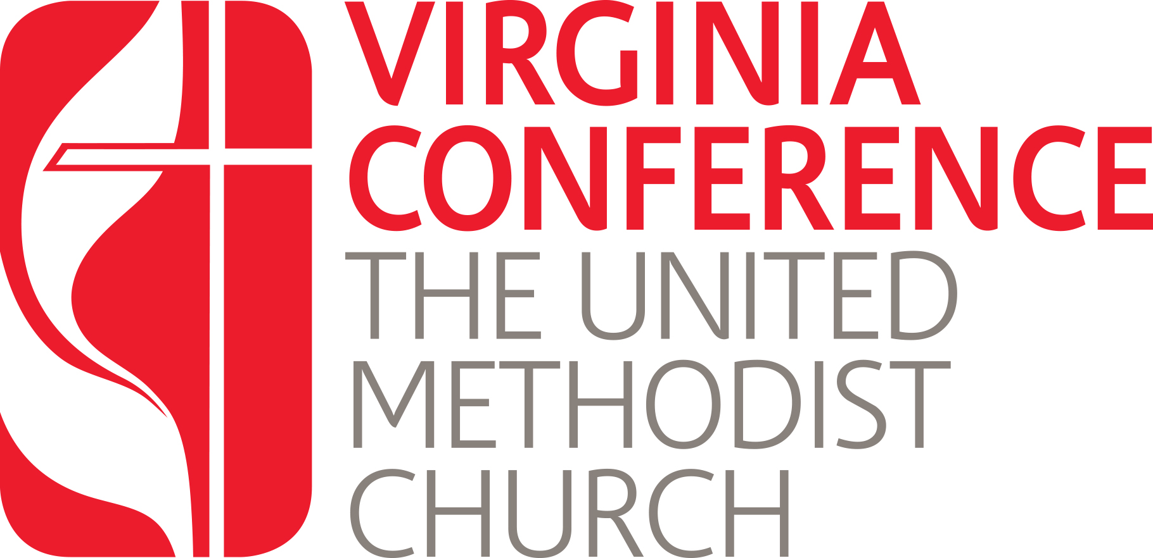
Center for Clergy Excellence
and the
Board of Ordained Ministry
www.vaumc.org/ClergyExcellence

As Provisional Members prepare for Full Membership interviews, the Center for Clergy Excellence would like to offer this list of clergy members as advisors and support. The following ordained clergy have volunteered to serve as readers, participating in mock interviews and generally offering insight to their experiences in applying to the Board. Their advice is their own and not that of the Board of Ordained Ministry.
The Center for Clergy Excellence hopes that these individuals may prove to be helpful to you in your ministry journey as Provisional Members.

Thomas James | Alexandria | ThomasJames@vaumc.org
Don Jamison | Alexandria | DonJamison@vaumc.org
Brian Johnson | Alexandria | BrianJohnson@vaumc.org
Christina Hart-Perkins | Alexandria | ChristinaHartPerkins@vaumc.org
Deborah Porras | Alexandria | DeborahPorras@vaumc.org
Michelle Kim | Arlington | MichelleKim@vaumc.org
Keith Lee | Arlington | KeithLee@vaumc.org
Rob Lloyd | Arlington | RobLloyd@vaumc.org
Jonathan Page | Arlington | JonathanPage@vaumc.org
Tom Frost | Charlottesville | TomFrost@vaumc.org
John Hemming | Charlottesville | JohnHemming@vaumc.org
Elizabeth Lutz | Eastern Shore | ElizabethLutz@vaumc.org
Rachel May | Eastern Shore | RachelMay@vaumc.org
Megan Saucier | Elizabeth River | MeganSaucier@vaumc.org
Kent Wise | Farmville | KentWise@vaumc.org
Debra Cline | Harrisonburg | DebraCline@vaumc.org
Tommy Crosby | Harrisonburg | TommyCrosby@vaumc.org
Courtney Joyner (Deacon) | Harrisonburg (EMSem.) | CourtneyJoyner@vaumc.org
Andrew Book | James River | AndrewBook@vaumc.org
Jacob Sahms | James River | JacobSahms@vaumc.org
Rob Lough | Rappahannock River | RobLough@vaumc.org
Craig Muffley | Rappahannock River | CraigMuffley@vaumc.org
Lyn Harding (Deacon) | Richmond | LynHarding@vaumc.org
Lisa McGehee (Deacon) | Richmond | LisaMcGehee@vaumc.org
Sarah Sealand | Richmond | SarahSealand@vaumc.org
Adam Sowder | Richmond | AdamSowder@vaumc.org
Drew Willson | Richmond | DrewWillson@vaumc.org
Lauren Lobenhofer | Roanoke | LaurenLobenhofer@vaumc.org
Lisa Barbery | York River | LisaBarbery@vaumc.org
Mina Sumpter |  | minasumpter@vaumc.org

