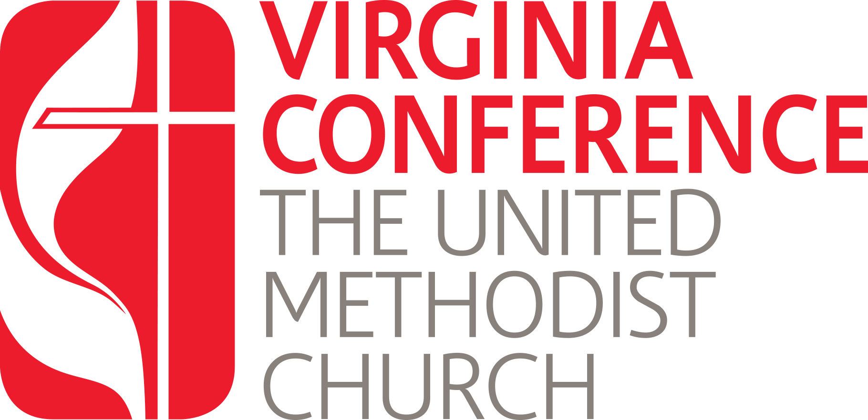

Certified Lay Minsters
Written Report on Ministry for Renewal of Certification

All Certified Lay Ministers (CLM’s) must renew their status every two years. The requirements for this renewal include candidates answering a series of questions which are then shared with the District Committee on Ordained Ministry (dCOM). Please use this Word document to answer the questions below.

Once you have completed your answers, you may save and upload this document into your Jotform application which can be found at: https://vaumc.org/lay-servant-ministries/required-forms-for-becoming-a-certified-lay-minister/certified-lay-minister-renewal-applications/

- Share your greatest joy since your last interview
- Share your greatest challenge since your last interview
- How do you take care of your health?
- How do you care for your spirit?
- How are you living out your calling in leadership in your local church? In the community?
- What lessons have you learned since your last interview

