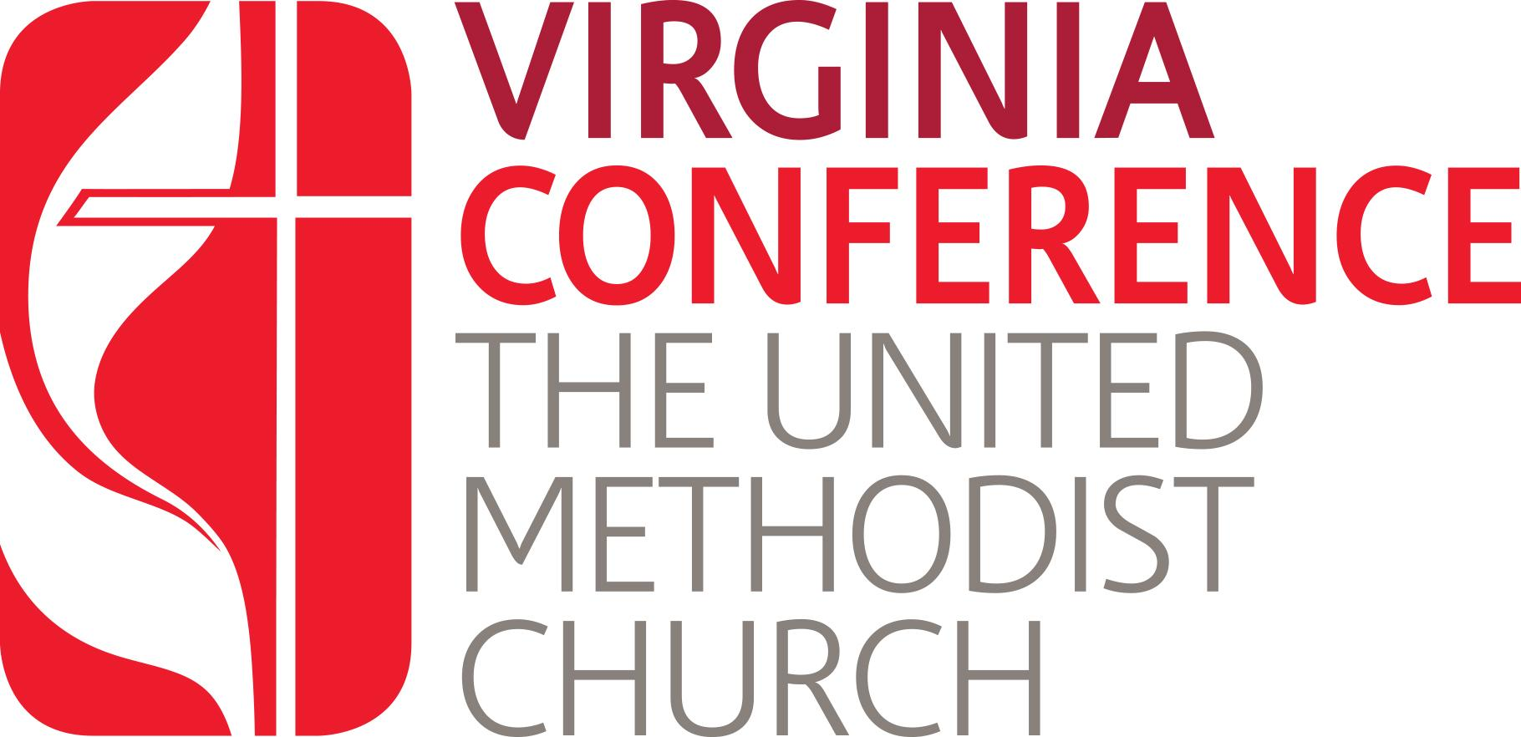
Master Checklist
for Entry Level Credentialing
in the United Methodist Church
Phase I - III

The journey to ministry in the United Methodist Church has many twists and turns. Luckily, there are people and all kinds of help along the way!
This checklist is provided to give candidates a way to track the requirements toward becoming credentialed in the United Methodist Church including expectations for interviews and their final Jotform Application.
This checklist covers the requirements for the following:
.Phase I: Inquiring Candidate → Admitted Candidate
Phase II: Admitted Candidate → Certified Candidate
Phase III: Certified Candidate → Licensed Local Pastor
If you have questions along the way, contact the program administrative coordinator LynHarding@vaumc.org, or the Associate Director for Call and Candidacy CrystalSygeel@vaumc.org
Let’s get started!

Phase I: Inquiring Candidate → Admitted Candidate

Step # | Action | Link | Date | Notes
1. | Download and fill out the biographical form | https://www.bomlibrary.org/wp-content/uploads/2016/12/Updated-Form-AA-102-Biographical-Information.pdf |  | Save it as a PDF to be uploaded when you fill out the Inquiring Candidate Steps form
2. | Write your call statement | Statement should be no more than two pages. Candidates need to be able to articulate their sense of call in a clear and concise manner. |  | Save it as a Word doc or PDF to be uploaded when you fill out the Inquiring
3. | Submit an expanded background check request | https://doc.vaumc.org/MinServices/ExtBackgroundCheckInstructions.pdf |  | Clergy Excellence will automatically be notified when the results are complete.
4. | Fill out the Phase I application which corresponds with your district | https://vaumc.org/clergyexcellence-candidacyforms/inquiring-candidate/ |  | Your dCOM chair/s will automatically be notified when you submit your application.
5. | Interview with your dCOM |  |  | Your dCOM will reach out to you to schedule an interview.
6. | Receive Mentor | If a candidate is accepted into candidacy studies, they are to be assigned a mentor. |  | The dCOM Mentor Coordinator will reach out to you and your mentor with an introductory email.

Phase II: Admitted Candidate → Certified Candidate
Step # | Action | Link | Date Completed | Notes for Final Application: Notation/Upload/Etc.
1. | Confirm Receipt of Mentor | Once you have become an Admitted Candidate, your dCOM will assign you a mentor. |  | Record the name of your mentor in the final Jotform application
 | Register with GBHEM ($$) | https://na.eventscloud.com/gbhemregistrationvaumc |  | Record the date of registration in final Jotform application
 | P/SPRC written materials (¶310.1d) | You will prepare these questions twice;  1. Once to meet with your S/PRC  2. Once to meet with your dCOM  Using Word Doc found at: www.vaumc.org/clergyexcellence-candidacyforms |  | Upload answers to final Jotform application
 | P/SPRC Recommendation | Your P/SPRC will provide you with this letter |  | Upload letter of Recommendation into final Jotform application
 | Candidate’s Declaration and Charge Conference Recommendation  Form | https://www.bomlibrary.org/wp-content/uploads/2016/12/Updated-Form-AA-104-Candidacy-Charge-Conf-Rec.pdf |  | Form requires the SIGNATURE of your DISTRICT SUPERINTENDENT.  Upload signed and completed form into your final Jotform application
 | Candidate’s Disclosure Form | https://doc.vaumc.org/minservices/Form114CandidatesDisclosureForm.pdf |  | Upload NOTARIZED form in final Jotform application
 | Plan to Attend Candidacy Summit | https://vaumc.org/candidacysummit/  Two summits are offered (January and July)  Candidates choose one. Fee: $75.00 |  | Record date of attendance or plans for future attendance in final Jotform application  Option to upload Certificate of Completion
 | Complete Emotional and Social Competency Inventory | Request assessment from: LynHarding@vaumc.org with Request for ESCI in subject line |  | Upload final report from the inventory in Jotform application.
 | Psychological Assessment ($$$) | The link to this request form can be found here: https://form.jotform.com/222634906069056 |  | Note if you have requested your psych evaluation in the Jotform application.  Clergy Excellence will put a copy of your final assessment in your basecamp folder for your dCOM to review.
 | Medical Report Form | https://doc.vaumc.org/minservices/ClergyMedicalReportForm.pdf |  | Note if you have met with your doctor in the Jotform application.  Your doctor will submit the form to clergy excellence.
 | Written response to ministry questions (Book of Discipline ¶310.2a) | https://vaumc.org/clergyexcellence-candidacyforms/ |  | Upload answers to final Jotform application
 | Candidacy Mentor Report | Your mentor will fill out a final report on your process together. The link to that form is below. When they receive a copy of the report, they will share with you to upload.  https://form.jotform.com/221955494741060 |  | Upload this report from your mentor
 | Fill Out the Phase II Application that corresponds to your district | https://vaumc.org/clergyexcellence-candidacyforms/admitted-candidate-forms/ |  | When you complete the application it will automatically be sent to your dCOM Co/Chair

Phase III: Certified Candidate → Licensed Local Pastor

Step # | Action | Link | Date | Notes
1. | Write, preach/record & describe a sermon of your choosing |  |  | You will need to create a youtube link for your sermon to post in your final application
2. | Provide written responses to a series of questions | Link to the series of questions |  | Save it as a Word doc or PDF to be uploaded when you fill out the final application
3. | Provide the date you became a Certified Candidate | Note: Phase II and Phase III can be worked simultaneously. You may be certified and recommended for the licensing in the same interview. In this case you can put the projected date of the dCOM meeting.
4. | Request an Interview to be Recommended for Licensing | https://vaumc.org/clergyexcellence-candidacyforms/licensing-as-local-pastor-steps/ |  | Your dCOM chair/s will automatically be notified when you submit your application.
5. | Interview with your dCOM |  |  | Your dCOM will reach out to you to schedule an interview.
6. | Attend Licensing School | Licensing School is required by the BOD and takes place for eight days somewhere in the VAUMC. LS involves 80 contact hours of combined pre-coursework and on-site learning |  | You will be formally invited by your District Superintendent to attend.

