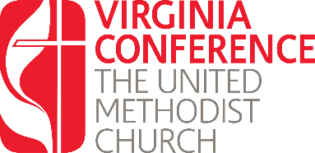
Phase III: Certified Candidates working toward Becoming a Licensed Local Pastor
Written Responses

All Certified Candidates pursuing the requirements to become a Licensed Local must answer questions which demonstrate basic knowledge of United Methodist theology and polity. Please use this Word document to answer the questions below.
Once you have completed your answers, you may save and upload this document into your Jotform application which can be found at: https://vaumc.org/clergyexcellence-candidacyforms/licensing-as-local-pastor-steps/

Basic Questions on United Methodist Theology and Polity
1) What is the meaning and significance of the Sacraments?
2) Talk about the nature of the Kingdom of God and then use a Biblical parable to illustrate one aspect of the Kingdom.
3) What is your understanding of the Wesleyan concept of divine grace?
4) How will you discern and implement God's vision for your ministry setting?

