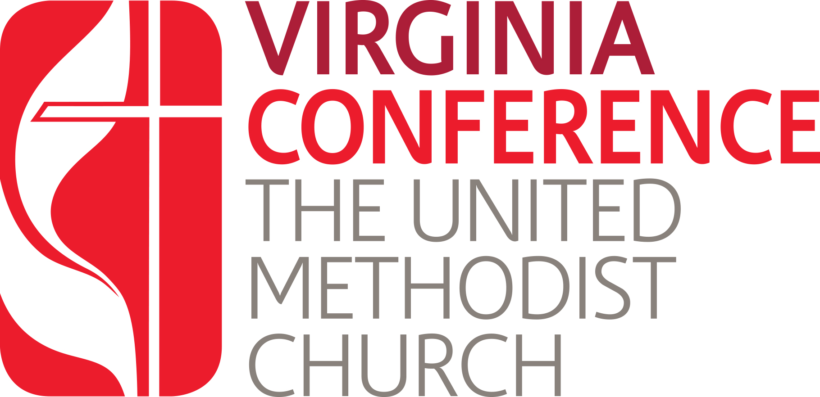

Virginia Conference Board of Ordained Ministry

Renewal Policies
For Diaconal Ministers and Certified Professionals

Note: Renewal for diaconal ministry is required annually. Renewal for professional and paraprofessional certification is required every other year, on the even years.

- Annual renewal for diaconal ministers and bi-annual renewal for professional and paraprofessional certification is required by the Board of Ordained Ministry and the General Board of Higher Education and Ministry.

- Continuing education requirements are specified in the Continuing Education Policies of the Board of Ordained Ministry. The requirement is a minimum of 1 CEU annually and 8 per quadrennium.

- If a person fails to fulfill any of the minimum standards for renewal, the reason shall be given in writing to the Board of Ordained Ministry. This information will be used by the Certification Committee, which reviews and recommends to the Board all renewals.

- If a person fails to fulfill any of the minimum standards for renewal for a second time, even if different reasons from the first time, the person may request a meeting with the Certification Committee of the Board of Ordained Ministry to work out a solution. The information from this meeting will be used in making a recommendation to the Board of Ordained Ministry.

- For persons who are not employed, a report indicating professional activities must be attached to the renewal form. Types of workshops, seminars, or leadership training events, number of hours spent, and a summary evaluation from participants of the event must be included. Local church involvement must also be included.

- If certification is allowed to lapse by failure of the certified person to seek renewal or to meet the standards of renewal, and later the person wishes to renew the certification, the Certification Committee will consider reinstatement based on the circumstances related to the discontinuance and the qualifications of the applicant.

- Those diaconal ministers who serve through United Methodist church-related agencies, ecumenical agencies, and those who serve through ministries which extend the witness and service of Christ's love and justice in the world through equipping persons to fulfill their own calls to Christian service will submit annually to the board:

                - A copy of the performance evaluation by the employing agency.
                - An outline of his/her involvement in the local church, district, and/or annual conference.
                - A letter from the pastor of the local church and, if applicable, a letter from the district superintendent telling how she/he has been able to make use of the diaconal minister's gifts and what plans she/he has for future use of these gifts.
                - A statement verifying that she/he has attended the charge conference and has filed a report
Revised 2/2004/ Updated 12/2024

