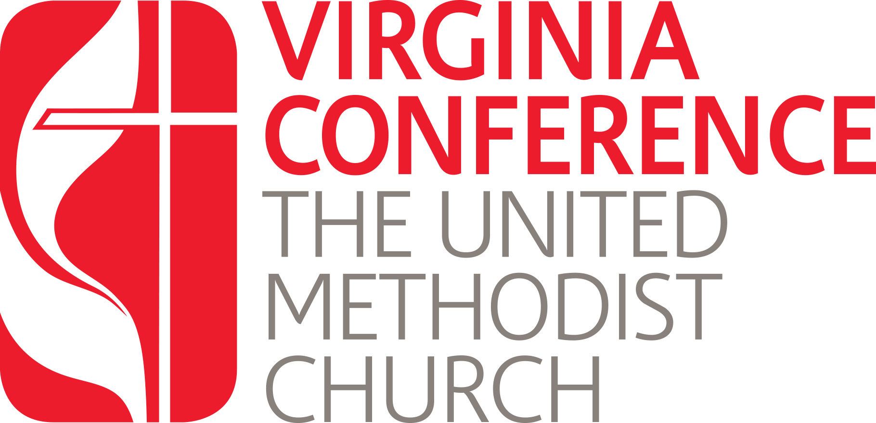

Phase II: Admitted Candidates working to become Certified Candidates
Written Responses to Questions on Ministry

All Admitted Candidates pursuing the requirements to become a Certified Candidate must answer the Ministry Questions to demonstrate fitness for ministry. Please use this Word document to answer the questions below.

Once you have completed your answers, you may save and upload this document into your Jotform application which can be found at: https://vaumc.org/clergyexcellence-candidacyforms/admitted-candidate-forms/

Written responses to Ministry Questions

These are the same series of questions you have prepared above for your P/SPRC Recommendation.

Please note* While your answers might not change significantly, your answers should reflect some variety and growth in your journey.

The full set of answers should be no less than two pages and no more than 4 pages. Your answers should be concise, grammatically correct, and include examples where appropriate.

Ministry Questions:

(1) The most formative experience of your Christian life
(2) God’s call to licensed or ordained ministry and role of the church in your call
(3) Your beliefs as a Christian
(4) Your gifts for ministry
(5) Your present understanding of your call to ministry as elder, deacon or licensed ministry
(6) Your support systems.

