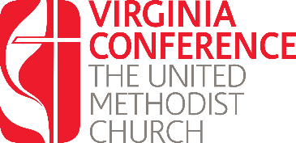
License Renewal:
Written Responses Year Three

Using this form respond the questions listed in preparation for your interview with the District Committee on Ordained Ministry. Once you have completed these questions, upload them into the renewal application found at www.vaumc.org/clergyexcellence-candidacyforms

- How has your preaching improved since you were licensed?
- In what ways have your spiritual disciplines affected your practice of leadership in ministry?
- Describe ways you lead your congregation in offering pastoral care?
- Bring a recent worship bulletin & be prepared to talk about your order of worship.
- Describe ways that, in partnership with laity, you make disciples of Jesus Christ, & train, empower these disciples to produce tangible fruits of love of God & love of neighbor.

Again, once you have completed these questions, upload them into the renewal application found at www.vaumc.org/clergyexcellence-candidacyforms

For questions contact the Associate Director for Call and Candidacy: CrystalSygeel@vaumc.org

