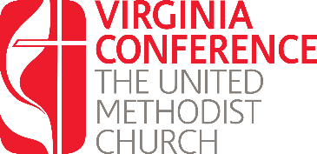
License Renewal:
Written Responses Year Four and Beyond

Using this form respond the questions listed in preparation for your interview with the District Committee on Ordained Ministry. Once you have completed these questions, upload them into the renewal application found at www.vaumc.org/clergyexcellence-candidacyforms

- What are your spiritual disciplines and/or resources you use in your ministry?

- What is your greatest joy in ministry?

- What has been your greatest area of growth this past year?

- What has been your greatest area of challenge this past year?

- How is it with your soul?

- In what ways can the DS, DCOM, and local church be supportive in your continuing education in ministry?

Again, once you have completed these questions, upload them into the renewal application found at www.vaumc.org/clergyexcellence-candidacyforms

For questions contact the Associate Director for Call and Candidacy: CrystalSygeel@vaumc.org

