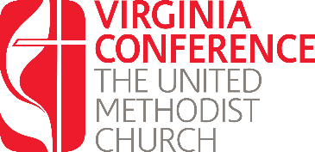
License Renewal:
Written Responses Year One

Using this form respond the questions listed in preparation for your interview with the District Committee on Ordained Ministry. Once you have completed these questions, upload them into the renewal application found at www.vaumc.org/clergyexcellence-candidacyforms

- What are the local church committees required by the Book of Discipline and what is the function of each?
- How is your church structured for mission and ministry?
- How are you using the distinctive Wesleyan emphases and characteristics of The United Methodist Church to lead your church in making disciples of Jesus Christ?
- Describe leadership qualities which you demonstrate in your ministry and the strengths & weaknesses of those qualities?

Again, once you have completed these questions, upload them into the renewal application found at www.vaumc.org/clergyexcellence-candidacyforms

For questions contact the Associate Director for Call and Candidacy: CrystalSyeel@vaumc.org

