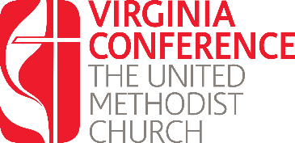
License Renewal:
Written Responses Year Two

Using this form respond the questions listed in preparation for your interview with the District Committee on Ordained Ministry. Once you have completed these questions, upload them into the renewal application found at www.vaumc.org/clergyexcellence-candidacyforms

- How do you apply United Methodist theology in your teaching?

- Describe ways your congregation lives out the theology of grace.

- In what ways has your theology of grace shaped your understanding of the Sacraments?

Again, once you have completed these questions, upload them into the renewal application found at www.vaumc.org/clergyexcellence-candidacyforms

For questions contact the Associate Director for Call and Candidacy: CrystalSyeel@vaumc.org

